Task 3: Project Crashing and Fast Tracking
Project Title: Final Year Project Management System
Group: 3
Course: BIT 3103
Date: October 2025
1. Modified Project Schedule
After analysis, we have identified tasks suitable for crashing and fast-tracking to reduce the original project duration from 72 days to 65 days, a reduction of 7 days.
WBS Code | Task/Activity | Original Duration (Days) | Crashed/Fast-Tracked Duration (Days) | Action Taken
3.2 | UI/UX Design | 3 | 2 | Crashing: Add a second designer
4.1 | Backend Development | 14 | 12 | Crashing: Allocate senior developer
4.2 | Frontend Development | 11 | 10 | Crashing: Use a UI component library
5.0 | Testing | 10 | 8 | Fast-Tracking: Start testing modules as they are completed, rather than waiting for the entire development phase to finish.
7.0 | Documentation | 7 | 5 | Fast-Tracking: Write user manuals in parallel with UAT.
The updated project timeline is as follows:
Task/ Milestone | Original End Date | Crashed End Date | Status
Requirement Gathering | 03/10/2025 | 03/10/2025 | Unchanged
System Design | 11/10/2025 | 10/10/2025 | Crashed
Backend Development | 25/10/2025 | 23/10/2025 | Crashed
Frontend Development | 05/11/2025 | 04/11/2025 | Crashed
Integration & Testing | 21/11/2025 | 19/11/2025 | Fast-Tracked
User Training & Deployment | 27/11/2025 | 25/11/2025 | Crashed
Final Report & Presentation | 01/12/2025 | 24/11/2025 | Crashed
2. Justification Report for Schedule Adjustments
Reason for Crashing/Fast-Tracking: The primary reason for compressing the schedule is to create a buffer for unforeseen delays (e.g., academic commitments, technical bugs) and to allow more time for the final presentation rehearsal. Reducing the timeline by one week mitigates risk and improves project resilience.
Impact Analysis:
- On Cost: Crashing incurs additional costs.
  - Adding a second designer and a senior developer will increase the labor cost. We estimate a 15% increase in the development and design budget line.
  - Using a premium UI component library may have a licensing cost (~$50).
  - Overall, the financial budget may increase by approximately $75,000 (from $500,000 to $575,000), which is considered acceptable for the benefit of a 10% reduction in project time.
- On Resources:
  - Human Resources: The designers and developers will face increased pressure and may need to work more hours during the crashed periods. This requires excellent coordination from the Project Manager to avoid burnout.
  - Technical Resources: Fast-tracking testing requires a more robust and modular development environment to allow isolated parts of the system to be tested independently.
Conclusion: The benefits of a shorter project duration—increased flexibility and reduced risk of missing the final university deadline—outweigh the moderate increase in cost and resource management complexity.
3. Diagram Showing Crashed/Fast-Tracked Tasks
This Gantt chart fragment visualizes the schedule compression, particularly showing the parallel execution (fast-tracking) of Development and Testing phases.
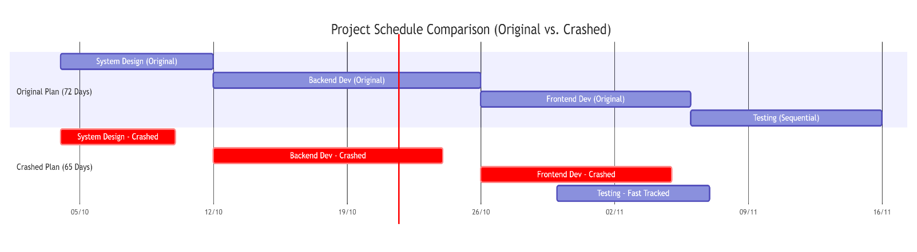
Explanation of the Crashed/Fast-Tracked Diagram
This diagram compares the original project timeline with a compressed one. It shows how we shortened the project by 7 days using two methods:
- Crashing: Making tasks shorter by adding more resources. You can see this in the shorter bars for Design, Backend, and Frontend.
- Fast-Tracking: Doing tasks in parallel instead of in sequence. This is shown by the Testing bar starting earlier and overlapping with Development.

